**2024英语组国际传播综合能力赛项校赛及省赛样题**

**Part I Read and Know**

**Questions 1-5**

Directions: Choose the best answer for each question.

1. Please complete the translation of “礼之用，和为贵”: Make ______ a top priority in the application of rites.

A. peace   B. harmony   C. agreement   D. cooperation

2. Please complete the translation of “四个自信”: the confidence in __________________ of socialism with Chinese characteristics.

A. path, theory, system and culture

B. path, economy, system and culture

C. path, theory, practice and culture

D. path, theory, system and ideology

3. Which of the following is the correct translation of “天下为公”?

A. Everyone is born equal.

B. The world belongs to all.

C. Justice is the most powerful.

D. The commonwealth benefits the people.

4. The meaning of “大信不约” is _________.

A. the greatest trust is not limited to pledges

B. the sincerest promise is not made through words

C. the most persuasive term is not written in agreements

D. the most influential belief is not recorded in holy books

In a bid to step up economic and social progress, it is imperative that all sectors work in unison. _______________________. The public and private sectors of the economy should be mutually reinforcing and beneficial; there is no need for conflict or strife.

—Xi Jinping: The Governance of China II

5. Which of the following sentences best fits in the blank?

A. A thing is yet to be done until it is done.

B. Clear waters and green mountains are invaluable assets.

C. The flame leaps high when everybody adds wood to a fire.

D. Distance tests a horse’s strength, and time reveals a person’s integrity.

**Questions 6-11**

Directions: Read the texts and answer the questions.



6. What do we know from the news?

A. The zoo was built specifically for filming the documentary series Tiger King.

B. Tiger King was an extremely successful documentary series about animal rights.

C. A federal judge found the cat zoo owner guilty of violating the animal welfare law.

D. All the big cats in the zoo were ordered to be transferred to the federal government.

As the saying goes: If your granny doesn’t recognise what’s in it, it’s probably not real food. Yet half the food we take home is made in factories from a list of ingredients and additives as long as your arm, most of which never found a place in any grandparents’ kitchen cupboard—and wouldn’t in yours or mine today.

The UK is a nation of ultra-processed-food eaters. Our lives have become too fast-paced to cook from scratch and our taste buds now crave the sweet and salty flavors that ultra-processed foods deliver. Our bread is fluffy and sticks to the teeth like candy floss. Our yogurts are super-sweet and creamy. We have ready meals that are shelf-stable (long life without refrigeration), which we can prise open, heat, eat and go.

7. What is the author’s attitude toward ultra-processed food?

A. Critical.   B. Impartial.   C. Defensive.   D. Mixed.

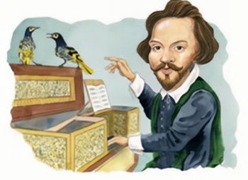

As if a declining population wasn’t bad enough, a rare species of bird in Australia has now forgotten how to sing. The falling numbers of the Regent Honeyeater mean that fewer adults are around to pass on to young males the melodies they need to know to attract a mate—a problem that can only **exacerbate** the current situation. Some hope lies in the fact that honeyeaters are famously good mimics, and so scientists are investigating if they can be retaught their vocal skills by artificial means in a lab. And perhaps, we cheekily suggest, our feathered friends could be taught some new tunes at the same time? A bit of William Byrd would be an obvious place to start...

8. What does the underlined word “**exacerbate**” probably mean?

A. settle

B. reduce

C. control

D. worsen

9. What is the best title for the text?

A. Songful Dismissal Proves a Worry for a Male Bird

B. Regent Honeyeaters Are Being Pushed to the Brink

C. A New Application of Artificial Intelligence in Music

D. Significance of Artificial Environment in Birds’ Singing

One thing to remember in our age of instant gratification is that friends aren’t found; instead, friends are made—crafted, really—over time. It takes 6 to 8 conversations before someone considers us a friend. We wish we could walk into a party, instantly connect, and walk out arm-in-arm with a new BFF (Best Friend Forever), but really it’s an incremental process. The good news is that the bar to start is low. It’s been shown again and again that, as long as we are mutually kind to each other, we become friends with whomever we see most often.    11    and repetition are key. So put yourself in situations where you see the same faces again and again: a dog park at the same time each morning, a weekly writer’s workshop, or a co-working space.

10. What factor is essential to friend-making according to the text?

A. Mutual affection.

B. Frequent contact.

C. Instant connection.

D. Face-to-face communication.

11. What is the missing word probably?

A. Inclusion

B. Attraction

C. Proximity

D. Diversity

**Questions 12-15**

Directions: Read the chart and decide whether the following statements are True or False.

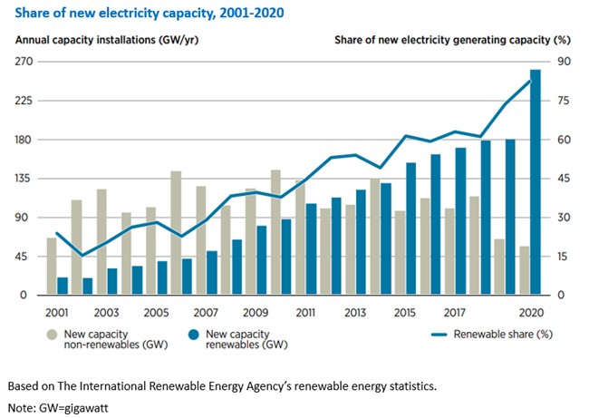

12. The chart reflects not only the steady and increasing growth in the use of renewables but also the continuous decline in the growth of non-renewable capacity.

True (   )   False (   )

13. The renewable generation capacity in 2020 was more than six times the non-renewable generation capacity.

True (   )   False (   )

14. The renewable generation capacity has accounted for more than half of total electricity generating capacity since 2015.

True (   )   False (   )

15. The renewable generation capacity has been greater than the non-renewable generation capacity since 2012.

True (   )   False (   )

**Part II Read and Reason**

**Questions 16-18**

Directions: Read the texts and answer the questions.

For novice exercisers, morning workouts are often the most dreaded. ①But morning workouts have their advantages. ②These chemicals, along with a few others, boost energy levels, alertness, and focus, which can make you more productive and attentive at work. ③Trading a cozy, nurturing bed for a sterile, unforgiving fitness center can be a rude awakening to say the least. ④Challenging the body triggers the release of endorphins, uplifting one’s mood following exertion.

16. What is the right order of the numbered sentences?

A. ③①④②   B. ④①②③

C. ③②④①   D. ④③②①

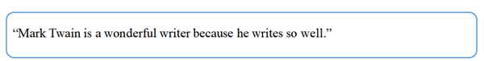

17. Which of the following commits the same logical fallacy as in the text?

A. “My professor, who has a Ph.D. in Astronomy, once told me that ghosts are real. Therefore, ghosts are real.”

B. “I don’t see how you can say you’re an ethical person. It’s so hard to get you to do anything; your work ethic is so bad.”

C. “It is possible to fake the moon landing through special effects. Therefore, the moon landing was a fake using special effects.”

D. “You should believe me because I’m an expert in this field, and how do you know I’m an expert? Well, because I have the knowledge and expertise.”

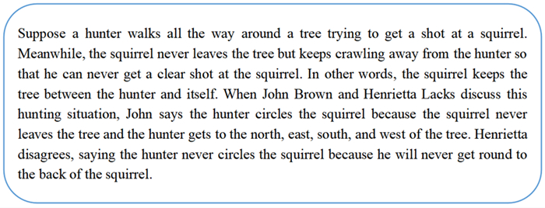

18. What can be concluded from the disagreement between John and Henrietta?

A. John lies when saying the squirrel cannot escape from the hunter’s circle.

B. John believes the hunter is flexible enough to finally get a clear shot at the squirrel.

C. Henrietta thinks the hunter can never get behind the squirrel and shoot it in its back.

D. Henrietta guesses it is the tree that blocks the hunter’s sight to accurately target the squirrel.

**Questions 19-25**

Directions: Read the texts and answer the questions.

Chinese company Space Transportation wants to take a jab at the growing space tourism market with a winged rocket capable of suborbital travel. The reusable space plane could take wealthy tourists to the edge of space and then land them on the other side of the world in no time.

Space Transportation was founded in 2018 and it managed to raise $46 million to develop its flagship supersonic spaceplane in August, 2021. Although details are still sparse, a video presentation on the company’s website shows passengers boarding a vertical plane attached to a glider wing with two boosters. Once it reaches a high altitude in the stratosphere, the airplane detaches from the auxiliary power, with the wing and boosters landing back on the launch pad on their own.

The developers behind the project seem pretty serious about it. So far, they’ve made 10 flight tests for the self-landing booster rockets, the last of which was done in collaboration with a combustion research lab from Tsinghua University.

In many ways, Space Transportation sounds like the Chinese version of Virgin Galactic and, to a lesser degree, SpaceX. In the summer of 2021, Virgin CEO Sir Richard Branson made headlines after he went on an 11-minute suborbital flight, reaching 55 miles (88 km) above the Earth’s surface. Just a week later, fellow billionaire Jeff Bezos made it past the Kármán Line, the internationally-recognized boundary of space, at nearly 62 miles (100 km) above the Earth’s surface, aboard a capsule launched by Blue Origin’s New Shepard reusable rocket.

Global space tourism is projected to reach just $1.7 billion by 2027, according to a report published in 2021. Virgin Galactic has hundreds of reservations for tickets on future flights, sold between $200,000 and $250,000 each. No reservation data has been made public by Blue Origin, but we can presume they’ll soon start making more commercial space tourism flights.

However, neither Virgin Galactic nor Blue Origin seems to be interested in point-to-point travel. In addition to potential space tourism flights, Space Transportation’s vehicle also doubles as a supersonic plane capable of traveling at more than 2,600 mph. SpaceX had plans for a similar concept when it announced its “Earth to Earth” project in 2017, which repurposes its Big Falcon Rocket originally meant to carry passengers to Mars. But Elon Musk’s company hasn’t released any details about this city-to-city passenger transport since then, which may mean it could have been scrapped entirely.

Perhaps SpaceX found city-to-city supersonic travel financially unfeasible, but Space Transportation doesn’t seem deterred. It is planning ground tests by 2023, the first flight by 2024, and a crewed mission by 2025. Looking farther into the future, the Chinese startup dreams of testing an orbital crew space vehicle, the kind that SpaceX uses to ferry crew and cargo to the International Space Station, by 2030.

19. Why does Space Transportation develop its flagship supersonic spaceplane?

A. To realize the reuse of space planes.

B. To fulfill the supersonic space travel plan.

C. To solve the problems of self-landing rockets.

D. To compete with Virgin Galactic, Blue Origin and SpaceX.

20. What can be learned about Virgin Galactic and Blue Origin?

A. Both have launched suborbital flights.

B. Both aim high at sending passengers to Mars.

C. Both have made a fortune from space tourism.

D. Both are interested in the exploration of outer space.

21. What is the purpose of the text?

A. To encourage wealthy people to reserve space flight tickets.

B. To show the fierce competition in the global space tourism market.

C. To disclose the technological bottleneck of self-landing rockets.

D. To report a Chinese company’s progress in developing supersonic rockets.

While technology and construction have progressed rapidly in recent years, allowing structures to be built taller and faster than ever, remnants of colossal ancient monuments remind us that construction techniques from as long as hundreds of years ago had enormous merit as well. In fact, many of the innovations of antiquity serve as foundations of modern construction, with the Roman invention of concrete serving as a **cogent** example. Other essential ancient construction techniques, such as the arch and the dome, are now often considered stylistic flourishes, with designs like the Met Opera House reinterpreting classical typologies in a modern context.

These reinterpretations have taken many different forms, ranging from the revived use of ancient materials to renewing ancient construction techniques. For example, a new type of rammed earth construction reimagines ancient sustainability from a material standpoint, transforming traditional rammed earth into the stronger cement-stabilized rammed earth (CSRE). Originally consisting of soil, water, and a natural stabilizer (animal urine, animal blood, plant fibers, or bitumen), rammed earth construction has existed for centuries, having been used in monumental ancient projects ranging from the Great Wall of China to Alhambra of Spain. However, CSRE mixes soil, water, and cement instead, improving the material’s strength by orders of magnitude. Yet the main ingredient still being local soil, CSRE thus crucially reduces the negative effects of transporting other materials. CSRE is also cheaper than many other more common building materials, making it a sustainable option for affordable housing as well. The Xi’an University of Architecture and Technology has explored using CSRE to help rural communities to build new houses, while the Western Australian Department of Housing has investigated using CSRE in remote indigenous communities.

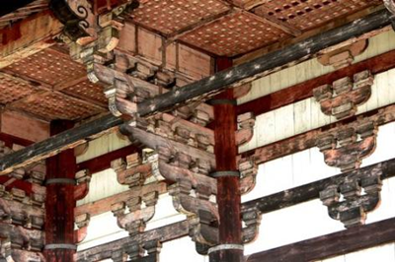

However, ancient construction materials and techniques are not only valued for their sustainability—building methods like the ancient Chinese dougong may be thousands of years old, but continue to be reinvented today for different structural and aesthetic needs. Consisting of a wooden bracketing system that once supported overhanging pagoda eaves without the need for nails, Chinese dougong is appreciated by contemporary architects like Kengo Kuma for its traditional significance and aesthetic potential. Kuma designed the unconventional Café Kureon using this technique. Similarly, He Jingtang utilized dougong to design the enormous and outward-expanding China Art Museum, which relies on the technique’s structural qualities to produce the building’s extraordinary tiered roof. Despite being an ancient construction method, contemporary architects thus continue to invent new ways of using dougong today.

With the field of architecture necessarily experiencing a kind of reinvention in light of the ongoing climate crisis, some innovators have looked back to the past in their search for successful and sustainable alternatives to common contemporary construction methods. Although many of these techniques rely on the small-scale use of local materials, it is possible that ancient construction methods may be applicable to large-scale structures as well. As reinventions of old techniques, these changes don’t necessarily constitute a step backward, but may indicate a more eco-conscious future instead.

22. Which of the following words is closest in meaning to the underlined word “**cogent**” in the first paragraph?

A. convincing   B. ancient   C. complex  D. innovative

23. Which of the following statements about cement-stabilized rammed earth (CSRE) is true?

A. It has led to an increase in construction costs.

B. It has applications in house building in China and beyond.

C. It is weaker than traditional rammed earth in terms of strength.

D. It is comprised of raw materials from various regions.

24. What can be learned about dougong from the third paragraph?

A. It was primarily used to build pagoda eaves.

B. It was solely present in ancient Chinese architecture.

C. It is employed today mainly to serve sustainable purposes.

D. It is creatively applied to modern constructions by architects.

25. Why do contemporary architects reinvent ancient construction techniques?

A. To achieve sustainability, structural and aesthetic needs.

B. To lower the construction costs for affordable housing.

C. To manifest aesthetic possibilities for modern buildings.

D. To mitigate the negative effects of transporting materials.

**Part III Write and Create**

Hellotravel is an online community where travel enthusiasts share their experiences and opinions on questions posted by global viewers. You happened to see a question by Tom Harris:

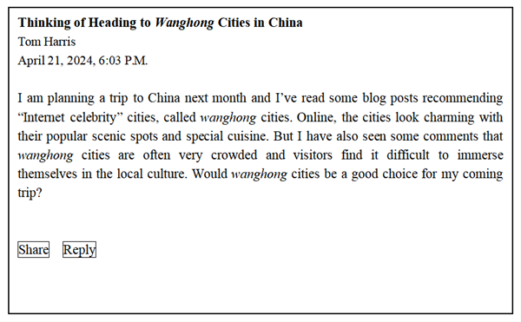

**Write him a reply and state your opinion with reasons and examples. You should write between 200 and 250 words.**

**参考答案：**

**Part I Read and Know**

1. B; 2. A; 3. B; 4. A; 5. C; 6. C; 7. A; 8. D; 9. A; 10. B; 11. C; 12. False; 13. False; 14. True; 15. False

**Part II Read and Reason**

16. A; 17. D; 18. C; 19. B; 20. A; 21. D; 22. A; 23. B; 24. D; 25. A

**Part III Write and Create**

（略）